Assessment Practice

Part A: View the trailer twice and then respond to the following questions
- What is the genre? Is the film animated, drama, documentary, comedy, sci-fi, adolescent, horror, etc.
- Narrative: how is the story told?
- Location: how does the trailer reveal location? what clues tell you so?
- Characters: describe the people portrayed in the trailer based on the info in the trailer
- Voice Over: who is the narrator?
- Theme: identify at least one theme based on the trailer
- Pacing: how is the trailer paced: fast, medium, slow? what impact might pacing have?
- On-screen graphics: what kind of info is revealed--be specific
- Music and other sound effects: what role do they play?

Part B: Annotate the following two images, identifying the visual conventions used (camera shots, angles, composition, mise-en-scene, etc). Explain the main ideas in each image.

Image 1

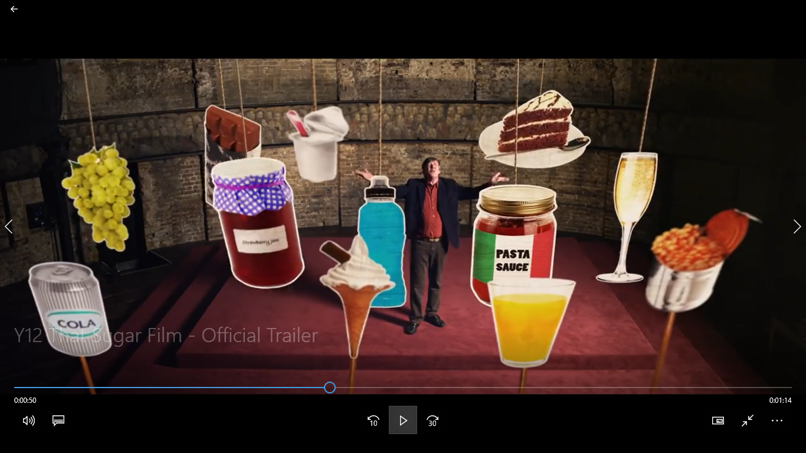

Main ideas:

________________________________________________________________________________

________________________________________________________________________________

________________________________________________________________________________

________________________________________________________________________________

________________________________________________________________________________
________________________________________________________________________________
Image 2

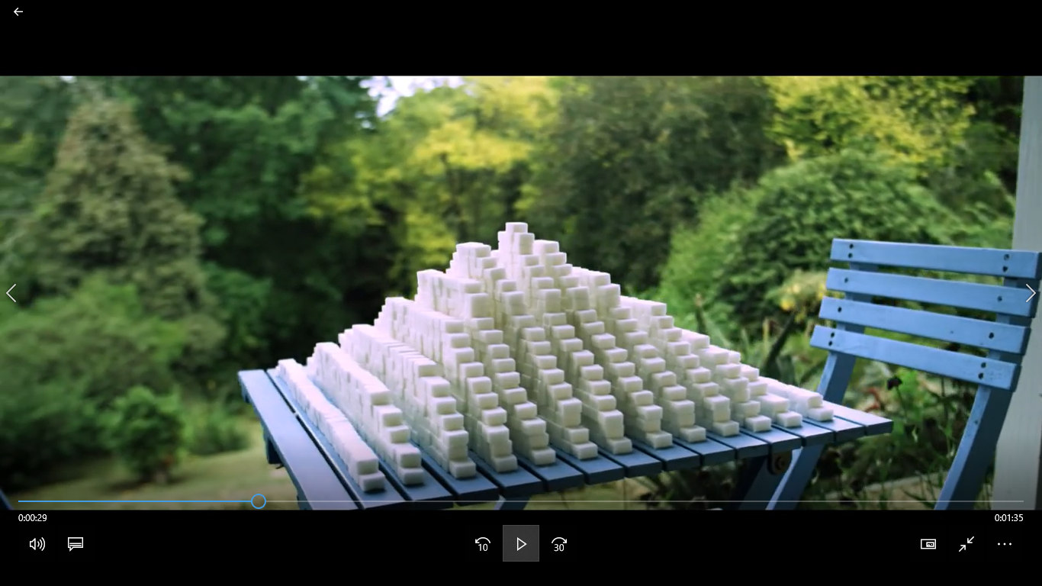

Main ideas:

________________________________________________________________________________

________________________________________________________________________________

________________________________________________________________________________

________________________________________________________________________________

________________________________________________________________________________
________________________________________________________________________________

